3.

a.

Below is the original image.

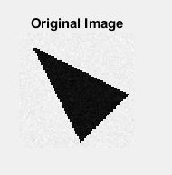

After applying a gaussian filter with standard deviation=0.5.

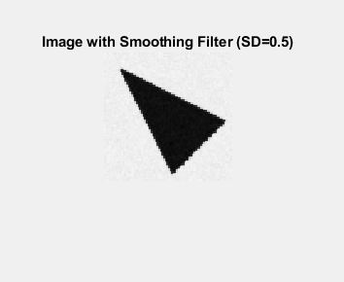

Using the Canny method to detect the edges.

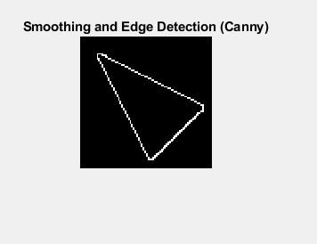

b.

Applying the Hough transform, choosing rho and theta resolution = 1 so as to create very local areas of high intensity voting and at the same time not too small of a resolution to make the location of the actual highest center of voting ambiguous.

There are 3 areas of significant voting.

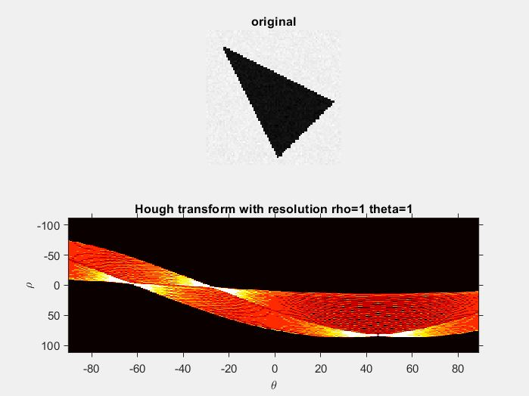

Analyzing this Hough graph, we see that the highest values, index pairs are

|  |  |  |
| --- | --- | --- |
| Value (number of votes) | Coordinates (60[col] by 77[row]) | (theta, rho) |
| 68 | 731 = 10, 38 | (-60,0) |
| 67 | 1657 = 22, 40 | (-24,6) |
| **62** | 653 = 9, 37 | (-63,-3) |
| **62** | 1735 = 23, 41 | (-21,9) |
| **62** | 3532 = 46, 67 | (47,87) |

Note that in the Hough transform matrix the 3rd highest value appeared 3 times. Two of these appearances are mere repeats of the 1st and 2nd highest theta,rho values.

To convert from (col, row) to (theta, rho),

Theta = -90 + ((89+90)/60)*col

Rho = -114 + ((114+117)/77)*row

Plotting and inspecting each (theta,rho) value on the graph and choosing the best fit,

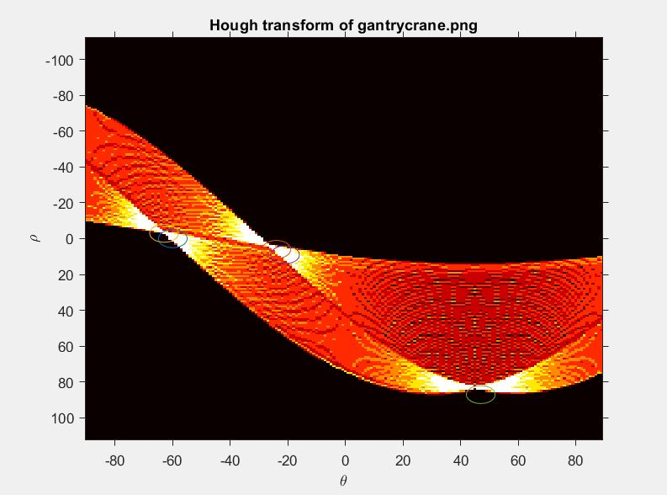

We choose (-63,-3), (-24,6), and (47,27) as the final 3 pairs.

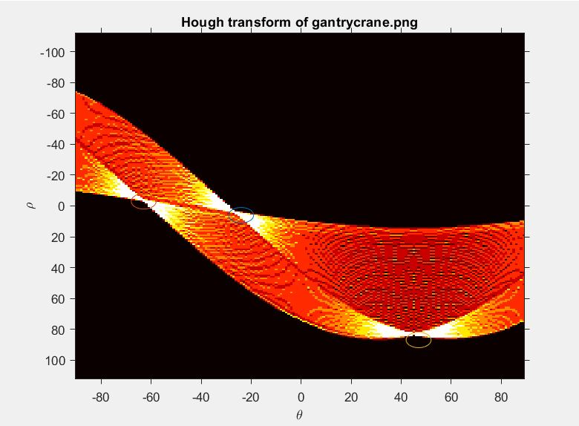

The plots of the 3 lines are below.

c.

remember to plot the lines in part b